Mars Sol
Send Feedback

In the documentation of the NASA API, you can see that the API also works with sol (Martian rotation or day) as input. This time we will take 'sol' and 'page' as input.

You need to do proper error handling in this too.

The NASA API is - https://api.nasa.gov/api.html#MarsPhotos

The web page looks like this -
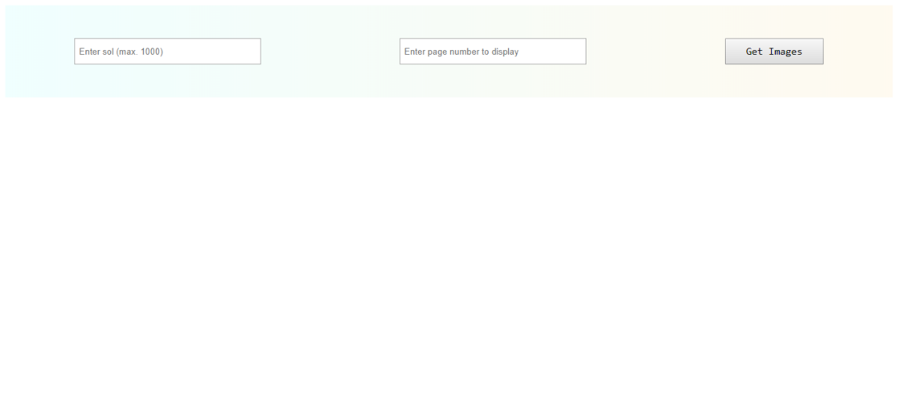

On entering the 'sol' and 'page', the web page would look like this -
